Use-care E-project Crossgame
- Use-case Diagram :
- Actor Admin :

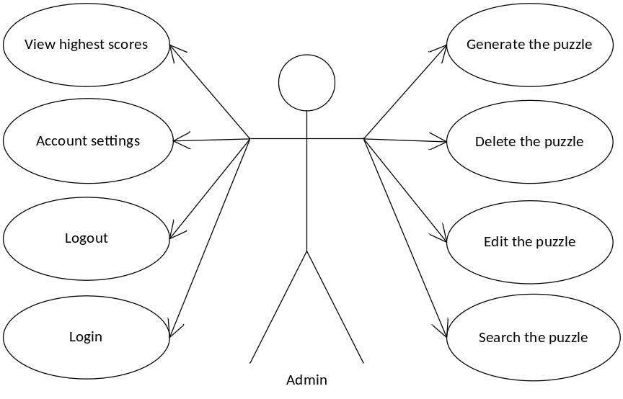

- Actor Player :

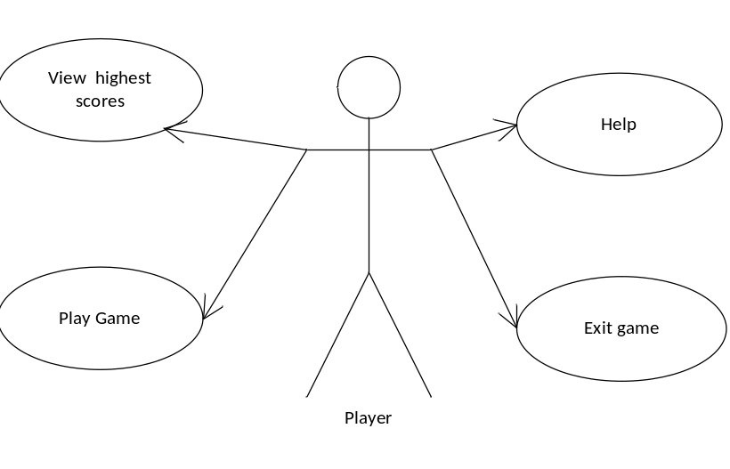

- Use-case Specification :
- List of Actors :
No | Actors | Comment
1 | Admin | Game manager
2 | Player | Those who play

- List of Use-case :
No | Use-case | Comment
1 | Login | Administrator logged into the system
2 | Logout | Administrator exit the system
3 | Account setting | Edit password of Administrator
4 | Generate the puzzle | Create a new puzzle from puzzles bank
5 | Delete the puzzle | Delete a puzzle from puzzle list
6 | Edit the puzzle | Edit a puzzle from puzzle list
7 | Search the puzzle | Find puzzle based on puzzle name or category
8 | View highest scores | Show Players have the highest scores, delete
9 | Player name | The empty place that Players can sign in their name
10 | New game | Show new game for Players
11 | Select game | Choice kind of games to play
12 | Play game | Play game . Show the score and right answer when Player finish Game
13 | View highest scores | Show Players have the highest scores
14 | Help | Introduce about Game and get some directions to play game.
15 | Exit game | Exit game

- Description
3.1 Use-case “Login” :
Use-case
Summary | Function login allows Administrator login to system with corresponding powers
Major events | Step1: when Administrator start, application form login will be displayed  Step 2: Administrator enter their Username and Password  Step 3: Press button “login” program will check Username and Password in database  Step 4: If exist program will display a confirmation message “ Login Successful”. Else program will display a confirmation message “Login Failed” and return Step1  Step 5: Administrator press button “ Exit” to exit this form.
Other events

3.2 Use-case “Logout” :

Use-case | Logout
Summary | Function “ Logout” help Administrator logout the program
Major events | Step 1: when Administrator want to sign out click “logout” on the program interface.  Step 2: Program will display a confirmation message “Do you want to sign out ?”  Step 3: If click “Yes” Administrator will exit program and disconnect with database. If click “No” Administrator will turn back application interface.
Other events

3.3 Use-case “Account setting ” :
Use-case | Account setting
Summary | Function “Account setting” help administrator change password
Major events | Step 1: Click on tab “Account setting”  Step 2 : Administrator enter their old password . Next , Administrator enter their new password  Step 3: click button “save”  Step 4 : the program will display a confirmation message “Do you want to change password ? ”  Step 5 : click “Yes” the password will be change to the database . Or click “No” the form will exit .
Other events

3.4 Generate the puzzle :
Use-case | Generate the puzzle
Summary | Function “Generate the puzzle” help administrator create puzzles
Major events | Step 1: Click on tab “Generate the puzzle”  Step 2:
Other events

3.5 Delete the puzzle
Use-case | Delete the puzzle
Summary | Function “Delete the puzzle” help administrator delete puzzles
Major events | Step 1: Click on tab “Delete the puzzle”  Step 2 : choose a puzzle and press button “Delete”  Step 3 : the program will display a confirmation message “Do you want to delete puzzle ? ”  Step 4 : click “Yes” the puzzle will be delete to the database and will be displayed on application . Or click “No” the form will exit .
Other events

3.6 Edit the puzzle
Use-case | Edit the puzzle
Summary | Function “Edit the puzzle” help administrator edit puzzles
Major events | Step 1: Click on tab “Edit the puzzle”  Step 2 : choose a puzzle and edited by Administrator  Step 3: click button “save”  Step 4 : the program will display a confirmation message “Do you want to edit puzzle ? ”  Step 5 : click “Yes” the puzzle will be change to the database . Or click “No” the form will exit .
Other events

3.7 Search the puzzle
Use-case | Search the puzzle
Summary | Function “Search the puzzle” help administrator Search puzzles
Major events | Step 1: Click on tab “Search the puzzle”  Step 2 : enter puzzle name or ID of puzzle then press button “Search”  Step3 : if the puzzle is exists in database : program will display information . Else program will display a confirmation message “No puzzle”
Other events

3.8 View highest scores
Use-case | View highest scores
Summary | Function “View highest scores” help administrator view , delete Player’s scores .
Major events | Step 1: Click on field “View highest scores”  Step 2 : program show the from “View highest scores”  If Administrator want to delete Player’s scores :  Step 3 : choose a Player’s scores and press button “Delete” .
Other events

3.9 Player name
Use-case
Summary | Function “Player name” help Player enter player name
Major events | Step 1: Click on field “player name”  Step 2 : Player enter player name . Player name will be save to the database
Other events

3.10 New game
Use-case | New game
Summary | Function “Player name” help Player start a new game
Major events | Step 1: Click on field “New game”  Step 2 : Program will show a new game give Player
Other events

3.11 Select game
Use-case | Select game
Summary | Function “Select game” help Player select a game genre suited for playing
Major events | Step 1: Click on field “Select game”  Step 2 : choose game genre suited for playing
Other events

3.12 Play game
Use-case | Play game
Summary | Function “Play game” help Player play game and show form Scores and answers
Major events | Step 1: Click on empty place  Step2 : enter key word on empty place  Continue Step1 and Step2 elsewhere until player complete .  Step 3 : press button “Submit” it will display form Scores and answers
Other events

3.13 View highest scores
Use-case | View highest scores
Summary | Function “View highest scores” help Player View highest scores
Major events | Step 1: Click on field “View highest scores”  Step 2 : program show the from “View highest scores”
Other events

3.14
Use-case | Help
Summary | Function “Help” help Player find out game
Major events | Step 1: Click on field “Help”  Step 2 : program show the file “Help”
Other events

3.15 Exit game
Use-case | Exit game
Summary | Function “exit game” help Player exit game
Major events | Step 1: Click on tab “Exit game”  Step 2 : program to stop working and automatically shut down
Other events

